|  |  |
| --- | --- |
| **McGill University**  **MATH 240 - Discrete Structures** | **Fall 2011**  **Prof Sergey Norin** |

# Review: Set theory

|  |  |  |  |  |  |
| --- | --- | --- | --- | --- | --- |
|  | **Comp.** | **Union** | **Intersection** | **Difference** | **Symmetric difference** |
|  | AC  A’ | A ∪ B | A ∩ B | A-B  A\B | A $⊕$ B  {a, b} ⊕ {b, c} = {a, c} |
|  | {x  |x ∈ U  ∧ x $∉$ A} | {x | x ∈ A ∨ x ∈ B} | {x | x ∈ A ∧ x ∈ B} | {x | x ∈ A ∧ x $∉$ B} | { x| (x ∈ A ∧ x ∉ B)  ∨ (x ∉ A ∧ x ∈ B)} |
|  |  | Venn Diagram for Union | Venn Diagram for Intersection | Venn Diagram for Set Difference | Venn Diagram for Set Symmetric Difference |
| **Closure**  Result is a set and always has a set value. | Closed | Closed  ∀ A, B ∈ ℘, (A ∪ B) ∈ ℘ | Closed  ∀ A, B ∈ ℘, (A ∩ B) ∈ ℘ | Closed | Closed |
| **Associativity**  Result does not depend on the order of evaluation |  | Associative  ∀A, B, C ∈ ℘,  ((A ∪ B) ∪ C) = (A ∪ (B ∪ C)) | Associative  ∀A, B, C ∈ ℘,  ((A ∩ B) ∩ C) = (A ∩ (B ∩ C)) | Not associative (A - B) - C ≠ A - (B - C) | Associative  (A ⊕ B) ⊕ C = A ⊕ (B ⊕ C) |
| **Commutativity**  Result does not depend on the order of the operands |  | Commutative  ∀A, B ∈ ℘,  (A ∪ B) = (B ∪ A) | Commutative  ∀A, B ∈ ℘, (A ∩ B) = (B ∩ A) | Not Commutative A - B ≠ B - A | Commutative  A ⊕ B = B ⊕ A |
| **Idempotency**  Union of any set with itself is the same value |  | Idempotent  ∀A ∈ ℘,  (A ∪ A) = A | Idempotent  ∀A ∈ ℘,  (A ∩ A) = A | Not  A - A = ∅ ≠ A | Not idempotent  A ⊕ A = ∅ ≠ A |
| **Left identity** |  | Empty set, ∅ or {}  ∀ A ∈ ℘, ∅ ∪ A = A | The universal set, U,  ∀ A ∈ ℘, U ∩ A = A | None | Empty set, ∅ A ⊕ ∅= A |
| **Right** **identity** |  | Empty set, ∅ or {}  ∀ A ∈ ℘, ∅ ∪ A = A | The universal set, U,  ∀ A ∈ ℘, U ∩ A = A | Empty set  A - ∅ = A | Empty set, ∅ A ⊕ ∅= A |

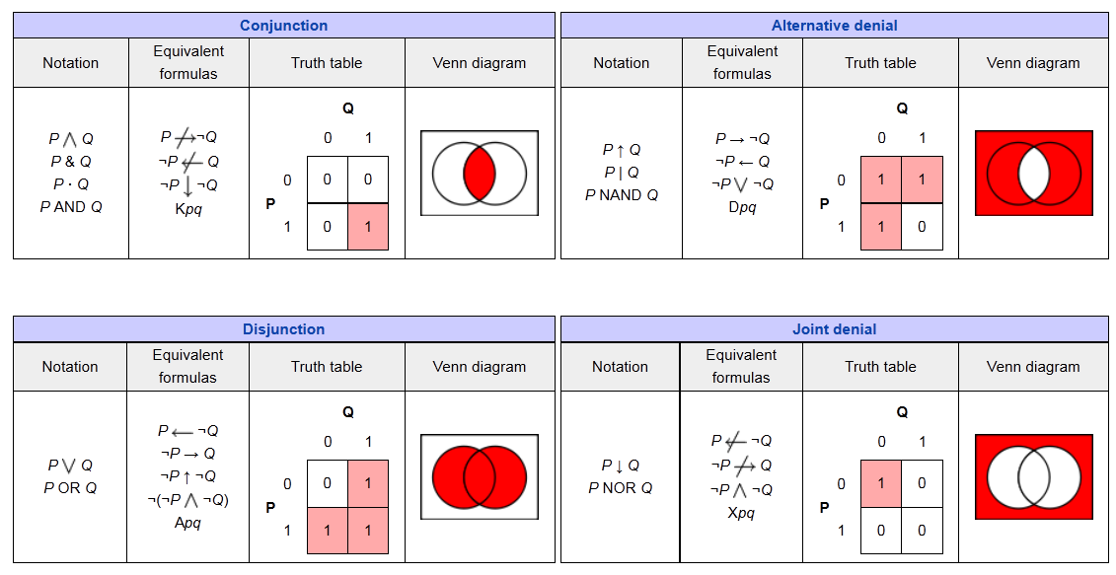

**Distributive identity**

Union over intersection

A ∪ (B ∩ C) = (A ∪ B) ∩ (A ∪ C)

Intersection over union

A ∩ (B ∪ C) = (A ∩ B) ∪ (A ∩ C)

**De Morgan laws**

De Morgan’s laws

De Morgan’s laws

**Other set properties**

difference set identity 

difference set identity 

difference set identity 

difference set identity 

A' U A = I

difference set identity 

Union Associativity

A U B

= (A ∩ B') U (A' ∩ B) U (A ∩ B)

A∩B =B- (B-A)

A\B = A $∩$ B’

(A\B) U B = A U B

(A\B) $∩$ B = ∅

A = (A\B) U (A $∩$ B)

A = (AUB) ∩ (AUB’)

A⊕B = (A-B) U (B-A)

A⊕B = (A U B)-(B U A)

(¬*A*) ⊕ *A* is always true

*A* ⊕ *A* is always false